If you already shop on Amazon.com
Follow these steps to switch to smile.amazon.com
Using your browser type in the address window: smile.amazon.com and hit ENTER
Sign in using your existing email and password for Amazon
Focus on this area
With your mouse CLICK on the upside down triangle to the right of “Account & Lists”
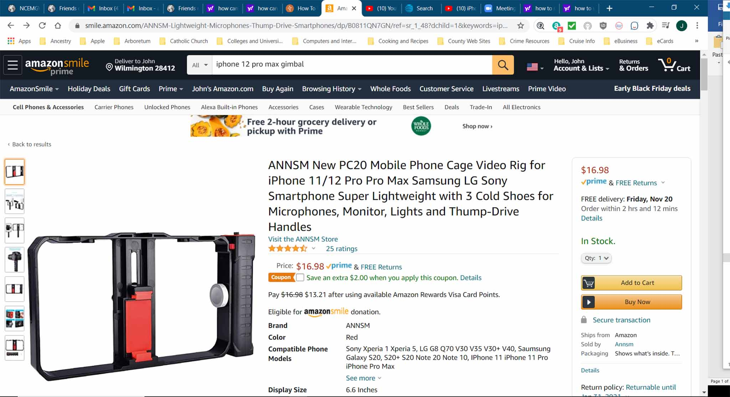

You will then see a drop down window appear with a variety of categories.
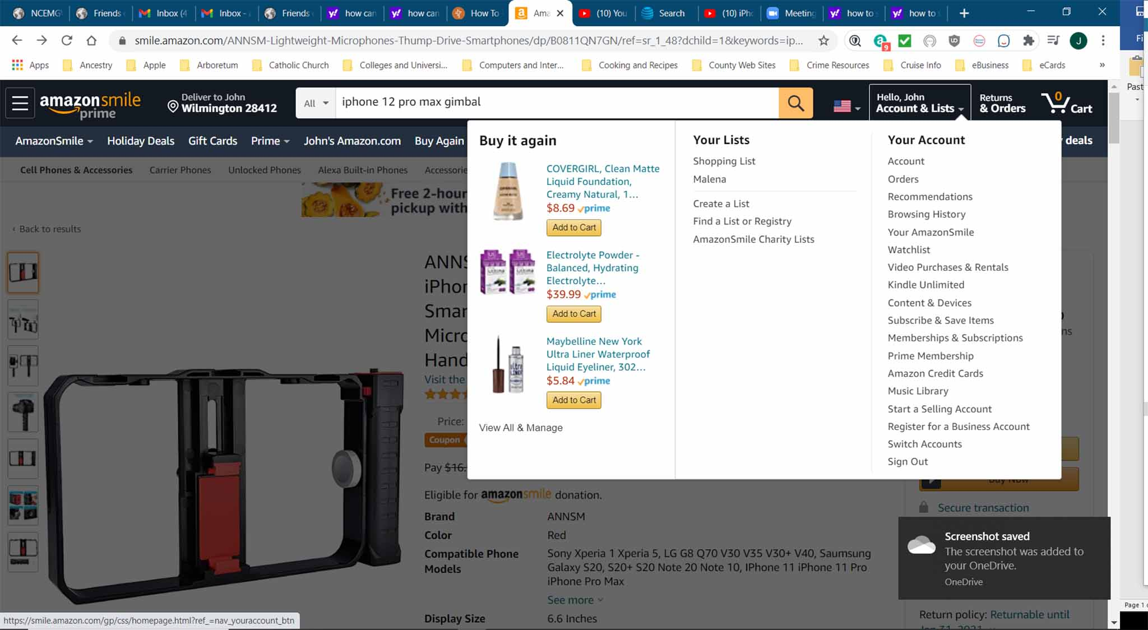
You will want to select “Your Amazon Smile” category
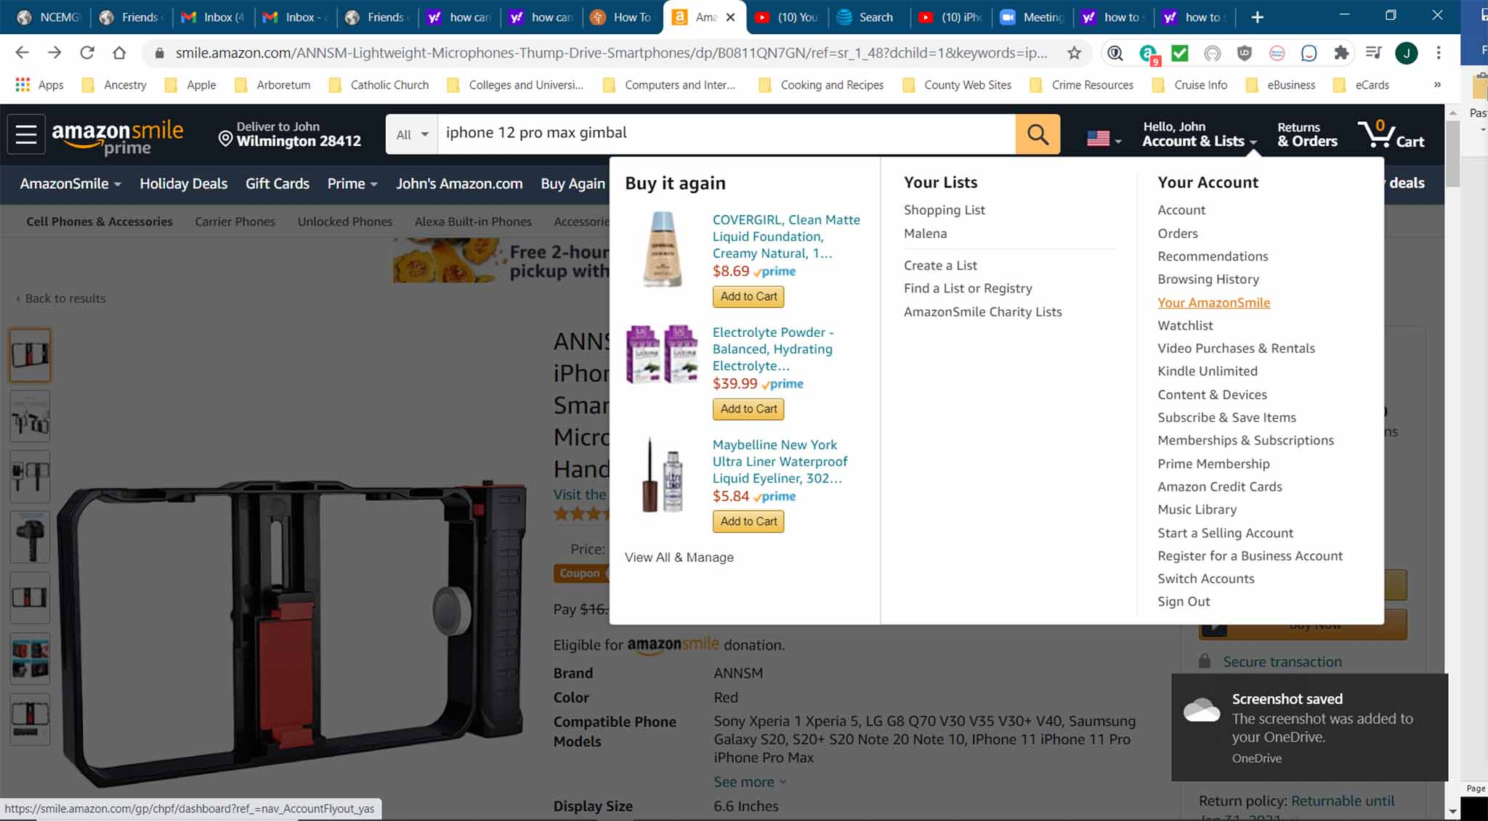

Click on that option and you will be taken to the following page. If you don’t already have identified a charity this page will be blank in terms of your impact (donations from your orders) on the left side and the name of the charity where the arrow is pointing. In that case, click on “Change Charity” under “Your Current Charity” OR below that, where the arrow is, it may say choose a charity. Click there.
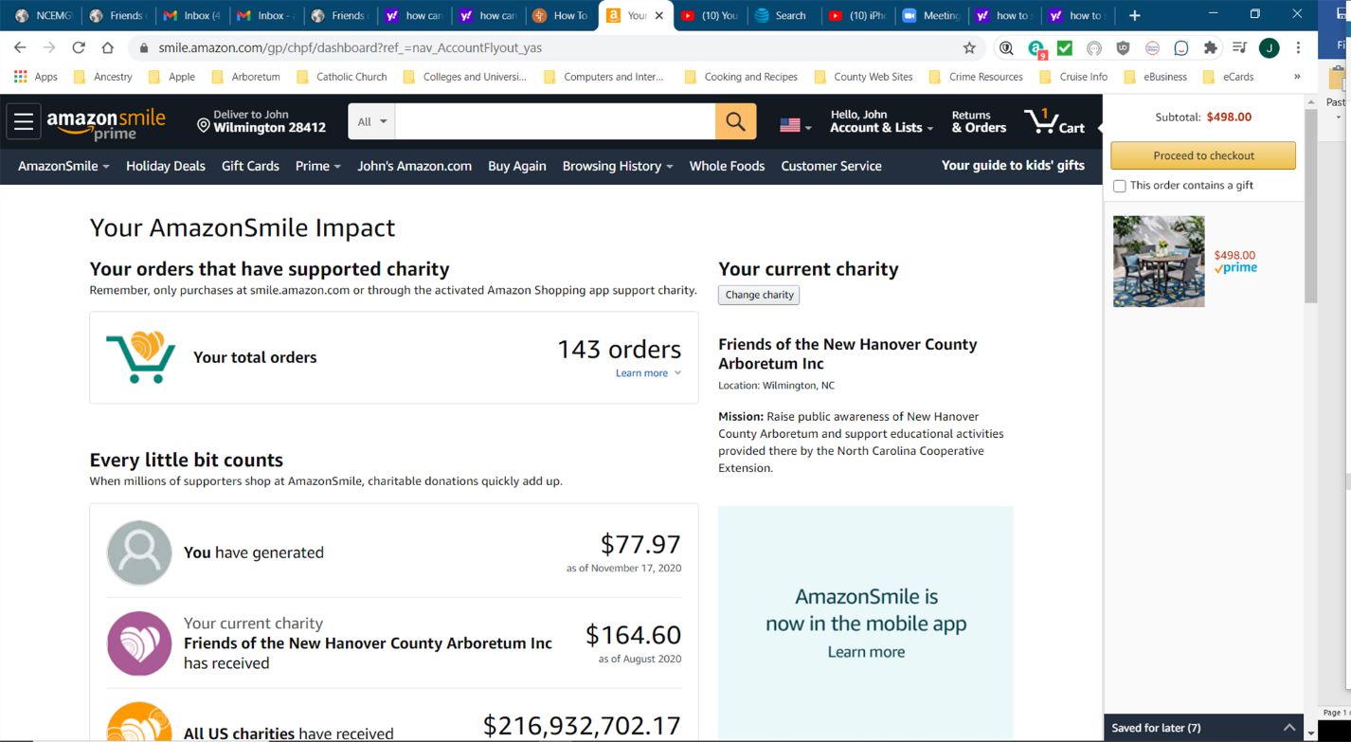
You may then see a page like this one. Enter the name of our charity and CLICK on the Search box.
Friends of the New Hanover County Arboretum Inc
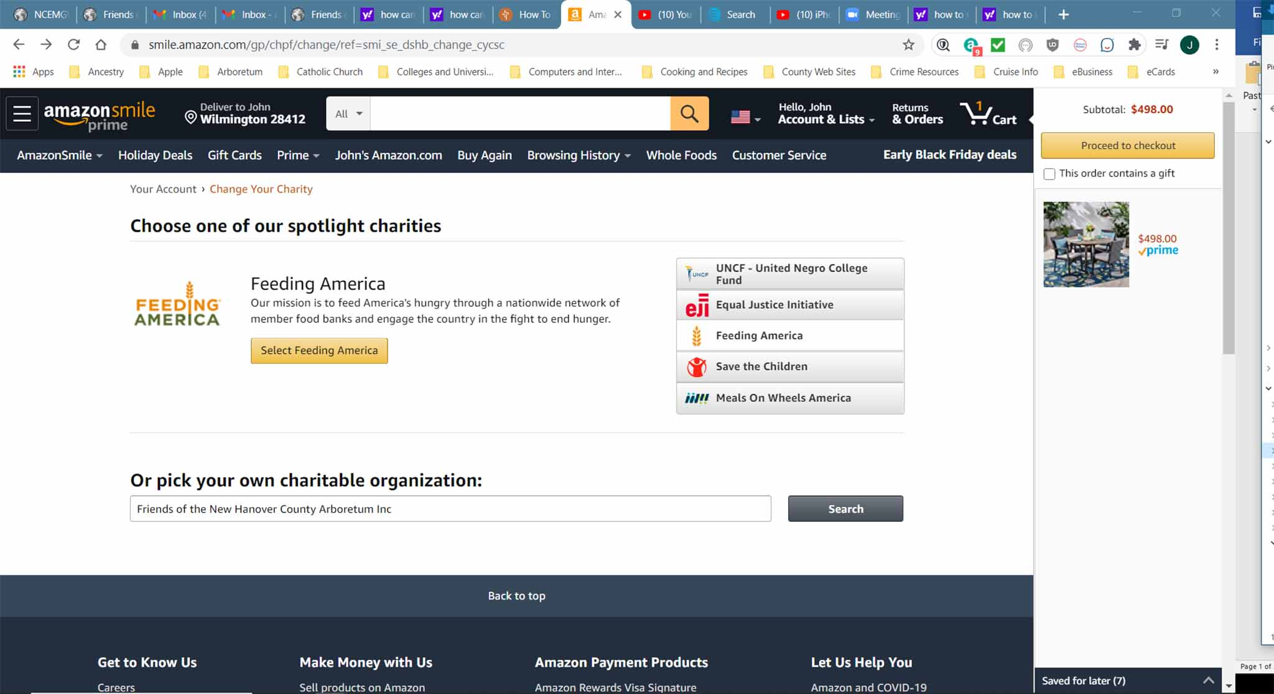
You’ll be taken to this next page. In the open space to the left of the SEARCH box type in the following:
Friends of the New Hanover County Arboretum Inc and CLICK Search.
The name will appear in the box below. Then CLICK “Select”
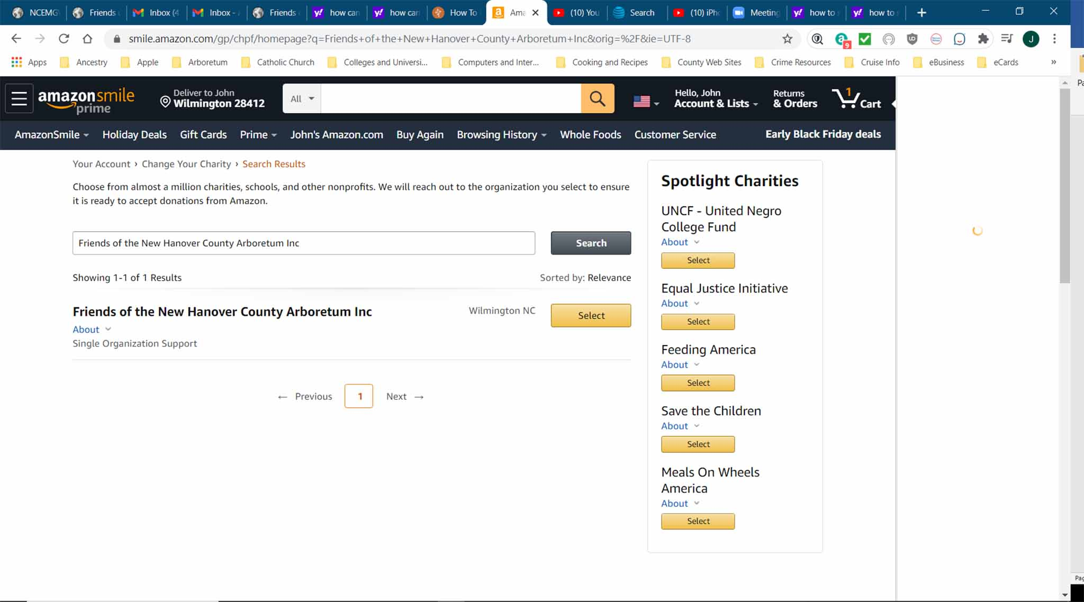

After CLICKING on the Select box you’ll be taken to the home page of your account. You are good to go.

