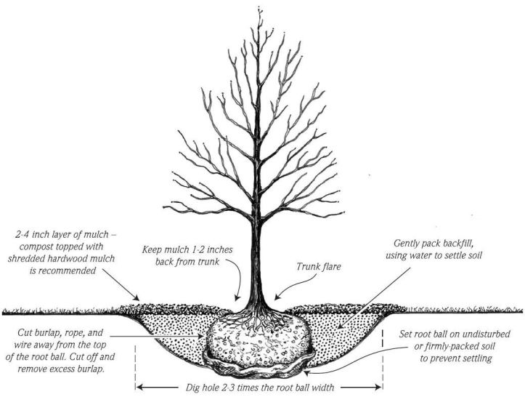

SUGGESTIONS:
- Always expose/look for root flare, remove any soil covering root flare prior to planting
- Plant approximately 2” above existing grade with sandy soils, about 3 – 4” above grade with heavy, wet soils
- Suggest 3” of Mulch or Pine Straw – no stone or bark chips (doesn’t hold moisture as well)
- Suggest adding a soil amendment such as Composted Cow Manure or Mirimichi Green Soil Enhancer (at Farmer’s Supply)
- Every week that it does not rain 1” of rain in a week, supplement with 10 gallons of water weekly per caliper of tree trunk, if extended hot and dry periods, supplement at least twice a week
- Use a slow acting fertilizer such as Plant Tone or Holly Tone.
- Stake trees only if necessary, they develop stronger anchor roots if they are allowed to develop naturally with wind movement. Remove stakes after 1 year.

